Metabolic modeling results section

**From 11-22-22 Slides**

Perhaps three overall topics to showcase how the model contributes to our understanding

1. ~~How we observe known metabolic phenotype patterns for each organism that align with their environmental niches (Glucose-acetate axis in E. coli, and PF lignin byproduct and organic acid consumption) Requires some creative writing based on literature precedents ☺ . Gen III data (coculture synergy for specific substrates).~~
2. Applying metabolic models to diverse substrates in biolog data – Key data to emphasize how the model can help predict complex interactions. ~~Cocultured organisms can have very different phenotypic dynamics due to metabolic interactions.~~ These can be predicted by PhenComm model. Introduce EC/PF competition as a simple model and revisit 4HB data from Gyorgy (rationale for distinct substrate choice for EC and PF).
3. Some simple engineering is predicted by metabolic models - ~~shutting down e. coli acetate consumption as a potential phenotype doesn’t significantly impact PF growth in coculture. This supports the idea that PF is consuming acetate before e. coli does. E coli consumes no acetate in the coculture.~~

**Results Outline –** *(Overall flow, but NOT numbers, based on slides)*

1. Initial metabolic characterization of organisms and challenge presented
   1. ~~Organism natural niches are reflected in their metabolic profiles on gen III plates~~
   2. Past met model methods predict gen III plate substrate utilization to X degree (?)
   3. Coculture data reveals metabolic interactions between species – (maltose)
   4. Same past met model methods cannot predict these interactions (?)
   5. Developed the PhenComm model as a versatile yet accurate model for predicting metabolites and organism phenotypes (RNA expression and protein activity?) over time in complex mixtures. Will build model and explore efficacy in test case
   6. No experimentally compatible PF specific substrate(?), so turned to more carbon sources and found 4-HB to be selective for PF. Armed with methods and metabolic tools (carbon sources) now ready to dive deeper into a particular metabolic interaction taking place when Maltose is present in coculture
2. Maltose, 4HB, and acetate
   1. Basic models, and literature precedents, predict that e. coli produces significant concentrations of acetate when consuming sugars aerobically. ~~We validated this in our hands by performing metabolomics to track acetate production at several stages of growth.~~ Indeed, acetate is produced, but then consumed, by E. coli
   2. We determined each organism’s response to acetate under different conditions as monocultures, making several findings that all point to E. coli being inhibited by high concentrations of acetate, and PF being a vigorous consumer of acetate
   3. We performed a battery of coculture experiments altering all carbon sources and compared each organism’s growth pattern to that of the monoculture. We saw several clear trends including decreased E. coli replication when cocultured with PF and consuming acetate as the only carbon source. We also performed metabolomics and observed significant changes in acetate production when E. coli are cocultured with PF. (RNA transcriptomics goes here as well)
   4. PhenComm model is improved greatly when X changes are made to account for Y discrepancies between the model and results
3. PhenComm predicts organism engineering
   1. Many research goals involve the alteration of an organism’s genome to alter its impacts whether bioproduction or microbiome modification. Gathered data from several KO strains that eliminate proteins involved in acetate consumption and production. Due to redundancy, most of these proteins had remarkably minimal effect on e coli metabolism, which in and of itself is surprising. PhenComm did/did not predict these engineering changes
   2. One gene KO, Pta, did completely eliminate e. coli’s ability to consume acetate. This major phenotypic change was modeled and compared to experimental results in monoculture and coculture with various carbon sources
   3. This KO strain followed our hypothesis that acetate forms the basis of syntrophy and that e. coli does not consume a significant amount of acetate in the coculture.
   4. ~~PhenComm predicted X characteristic from altering the entered genome and this mimicked altering the allowed phenotypes, specifically eliminating e. coli acetate consumption as an allowed phenotype~~
4. PhenComm predicts diverse coculture metabolic interactions
   1. Applied PhenComm to the genIII coculture dataset and was able to predict X% E. coli growth, Y% PF growth, and Z% interactions/noninteractions
   2. PhenComm performed particularly well with positive/negative coculture interactions, and with EC/PF growth
   3. PhenComm predicts that X molecule may be responsible for Y positive interaction literature precedents back this up
   4. PhenComm predicts that X molecule may be responsible for Y negative interactions literature precedents back this up

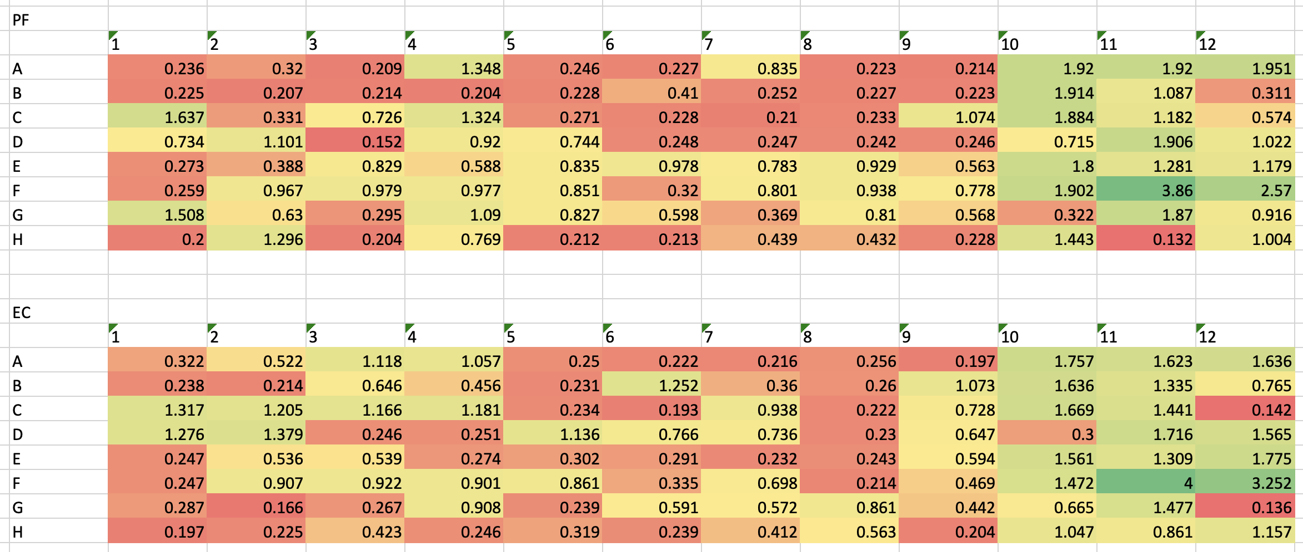



Figure 1. Metabolic utilization and stress response of E. coli and P. fluorescens monocultures via Biolog Gen III plates. A. Experimental data for P fluorescens. B. Experimental data for E. coli. C. Modeling approximations for P fluorescens. D. Modeling approximations for P. fluorescens

**Results Text –** Based on outline above

We first sought to characterize the monoculture metabolic utilization and stress response of each organism - *E. coli* MG1655 and *Pseudomonas fluorescens* SBW25. We observed many differences in carbon source utilization between the two bacteria, which is unsurprising given each organism’s metabolism was tuned in vastly different niche’s for millions of years (Figure !.A and B). Some specific observations highlight this difference…

Our group previously deployed dynamic flux balance analysis to predict metabolic profiles of diverse organisms. We applied this method to the metabolic profiling data acquired here and found the model agreed to X degree for E. coli and Y degree for P. fluorescens (Figure !.C and D). Description of results when acquired…

We next sought to explore whether metabolic models could be deployed to predict more complex facets of metabolism, specifically interspecies metabolic interactions.

Previous research has found E. coli excretes significant concentrations of acetate while processing rich nutrients such as glucose.